Que: Write a program to implement concurrent programming constructs through semaphores -dining philosophers' problem, consumer-producer, readers-writers etc.

1. Dining philosophers' problem
The Dining Philosopher Problem states that K philosophers seated around a circular table with one chopstick between each pair of philosophers. There is one chopstick between each philosopher. A philosopher may eat if he can pickup the two chopsticks adjacent to him. One chopstick may be picked up by any one of its adjacent followers but not both.
There are three states of philosopher : THINKING, HUNGRY and EATING. Here there are two semaphores : Mutex and a semaphore array for the philosophers. Mutex is used such that no two philosophers may access the pickup or putdown at the same time. The array is used to control the behavior of each philosopher. But, semaphores can result in deadlock due to programming errors.

PROGRAM:

#include<stdio.h>
#include<stdlib.h>
int tph, philname[20], status[20], howhung, hu[20], cho;
void main()
{
void one();
void two();
int i;
printf("\n\nDINING PHILOSOPHER PROBLEM");
printf("\nEnter the total no. of philosophers: ");
scanf("%d",&tph);
for(i=0;i<tph;i++)
{
philname[i] = (i+1);
status[i]=1;
}
printf("How many are hungry : ");
scanf("%d", &howhung);
if(howhung==tph)
{
printf("\nAll are hungry..\nDead lock stage will occur");
printf("\nExiting..");
}
else
{
for(i=0;i<howhung;i++)
{
printf("Enter philosopher %d position: ",(i+1));
scanf("%d", &hu[i]);
status[hu[i]]=2;
}
do
{
printf("1.One can eat at a time\t2.Two can eat at a time\t3.Exit\nEnter your choice:");
scanf("%d", &cho);
switch(cho)
{
case 1: one(); consumer-producer#include<stdio.h>
int n;
void main()
{
int findmax(int a[]);
int seq[30],fr[5],pos[5],find,flag,max,i,j,m,k,t,s;
int count=1,pf=0,p=0;
float pfr;
printf("Enter maximum limit of the sequence: ");
scanf("%d",&max);
printf("\nEnter the sequence: ");
for(i=0;i<max;i++)
scanf("%d",&seq[i]);
printf("\nEnter no. of frames: ");
scanf("%d",&n);
fr[0]=seq[0];
pf++;
printf("%d\t",fr[0]);
i=1;
while(count<n)
{
flag=1;
p++;
for(j=0;j<i;j++)
{
if(seq[i]==seq[j])
flag=0;
}
if(flag!=0)
{
fr[count]=seq[i];
printf("%d\t",fr[count]);
count++;
pf++;
}
i++;
}
printf("\n");
for(i=p;i<max;i++)
{
flag=1;
for(j=0;j<n;j++)
{
if(seq[i]==fr[j])
flag=0;
}
if(flag!=0)
{
for(j=0;j<n;j++)
{
m=fr[j];
for(k=i;k<max;k++)
{
if(seq[k]==m)
{
pos[j]=k;
break;
}
else
pos[j]=1;
}
}
for(k=0;k<n;k++)
{
if(pos[k]==1)
flag=0;
}
if(flag!=0)
s=findmax(pos);
if(flag==0)
{
for(k=0;k<n;k++)
{
if(pos[k]==1)
{
s=k;
break;
}
}
}
fr[s]=seq[i];
for(k=0;k<n;k++)
printf("%d\t",fr[k]);
pf++;
printf("\n");
}
}
pfr=(float)pf/(float)max;
printf("\nThe no. of page faults are %d",pf);
printf("\nPage fault rate %f",pfr);
}
int findmax(int a[])
{
int max,i,k=0;
max=a[0];
for(i=0;i<n;i++)
{
if(max<a[i])
{
max=a[i];
k=i;
}
}
return k;
}
break;
case 2: two();
break;
case 3: exit(0); break;
default: printf("\nInvalid option..");
}
}while(1);
}
}
void one()
{
int pos=0, x, i;
printf("\nAllow one philosopher to eat at any time\n");
for(i=0;i<howhung; i++, pos++)
{
printf("\nP %d is granted to eat", philname[hu[pos]]);
for(x=pos;x<howhung;x++)
printf("\nP %d is waiting", philname[hu[x]]);
}
}
void two()
{
int i, j, s=0, t, r, x;
printf("\n Allow two philosophers to eat at same time\n");
for(i=0;i<howhung;i++)
{
for(j=i+1;j<howhung;j++)
{
if(abs(hu[i]-hu[j])>=1&& abs(hu[i]-hu[j])!=4)
{
printf("\n\ncombination %d \n", (s+1));
t=hu[i];
r=hu[j];
s++;
printf("\nP %d and P %d are granted to eat", philname[hu[i]],
philname[hu[j]]);
for(x=0;x<howhung;x++)
{
if((hu[x]!=t)&&(hu[x]!=r))
printf("\nP %d is waiting", philname[hu[x]]);
}
}
}
}
}
OUTPUT:

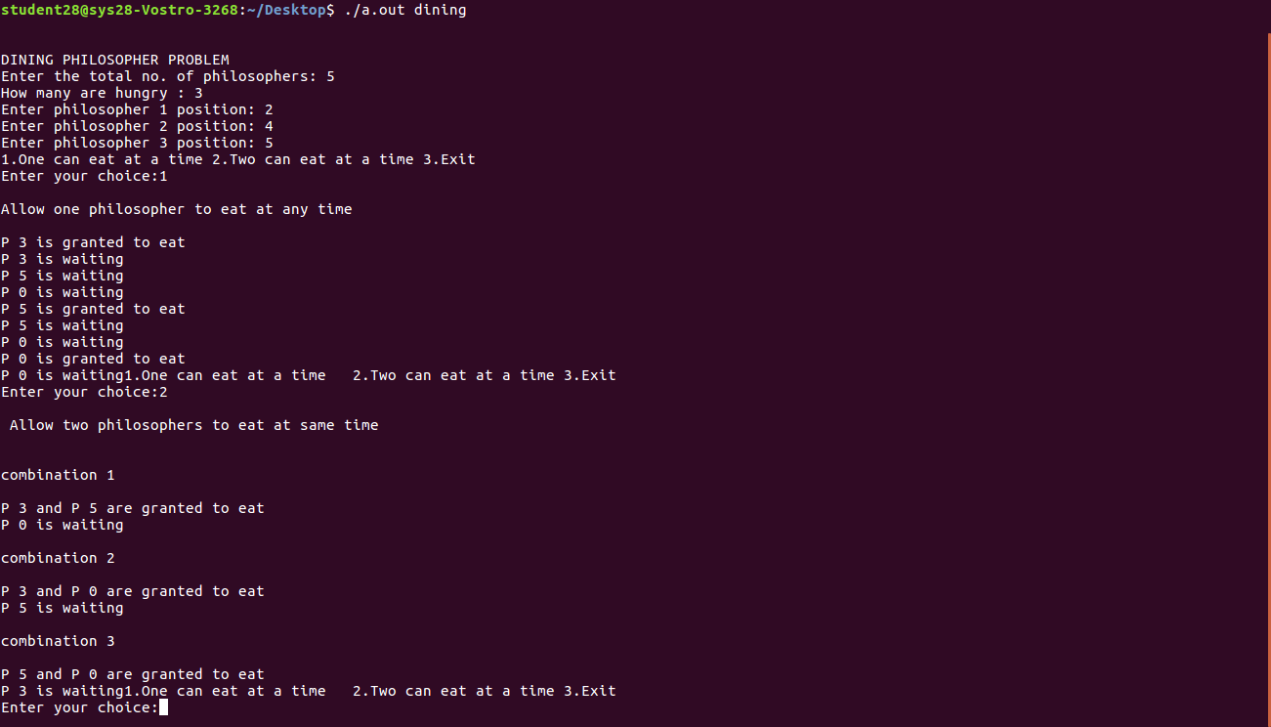

2. Consumer-producer:

Producer consumer problem is a classical synchronization problem. We can solve this problem by using semaphores. A Semaphore S is an integer variable that can be accessed only through two standard operations : wait() and signal(). The wait() operation reduces the value of semaphore by 1 and the signal() operation increases its value by 1.
Semaphores are of two types:

1. Binary Semaphore – This is also known as mutex lock. It can have only two values – 0 and 1. Its value is initialized to 1. It is used to implement the solution of critical section problem with multiple processes.
2. Counting Semaphore – Its value can range over an unrestricted domain. It is used to control access to a resource that has multiple instances.
Producer-consumer problem, is a common paradigm for cooperating processes. A producer process produces information that is consumed by a consumer process. One solution to the producer-consumer problem uses shared memory. To allow producer and consumer processes to run concurrently, there must be available a buffer of items that can be filled by the producer and emptied by the consumer. This buffer will reside in a region of memory that is shared by the producer and consumer processes. A producer can produce one item while the consumer is consuming another item. The producer and consumer must be synchronized, so that the consumer does not try to consume an item that has not yet been produced.

PROGRAM:

#include<stdio.h>
#include<stdlib.h>
void main()
{
int buffer[10], bufsize, in, out, produce, consume, choice=0;
in = 0;
out = 0;
bufsize = 10;
while(choice!=3)
{
printf("\n 1. Produce \t 2. Consume \t 3. Exit");
printf("\nEnter your choice: ");
scanf("%d",&choice);
switch(choice) {
case 1: if((in+1)%bufsize==out)
printf("\nBuffer is Full");
else
{
printf("\nEnter the value:");
scanf("%d", &produce);
buffer[in] = produce;
in = (in+1)%bufsize;
}
break;
case 2: if(in==out)
printf("\nBuffer is Empty");
else
{
consume = buffer[out];
printf("\nThe consumed value is %d", consume);
out = (out+1)%bufsize;
}
break;
}
}
}

OUTPUT:

